3.7 Tangent Planes and Normal Vectors

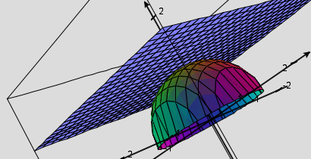
In this section we are interested in how to find the equation of a tangent plane to a surface at some point on the surface.

Motivation: Suppose that is a surface with equation where k is a constant and F has continuous first partial derivatives. Let C be an arbitrary smooth curve that lies on and passes through the point P: .

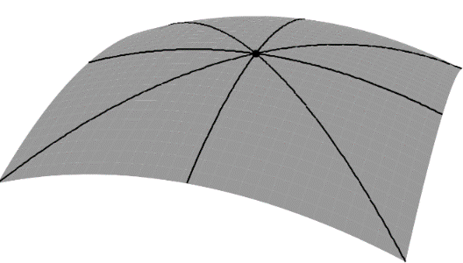

Definition: The tangent plane to the level surface at the point P: (assuming F has continuous first-order partials) is the plane given by the equation:

Note: In order for the above definition to work we need the gradient to be nonzero at our point of interest. We will say there is no tangent plane when the gradient is the zero vector at our point of interest.

Question: How would the above results change if we were dealing with level curves of the form ?

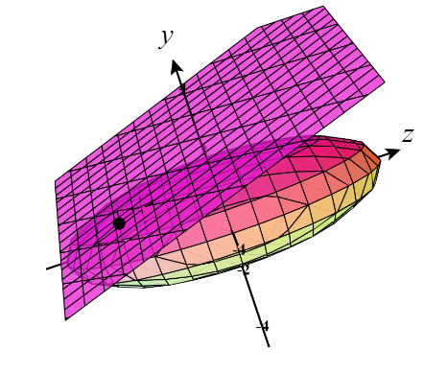
Example 1: Find an equation of the tangent plane at the point to the ellipsoid given by .

Motivation: Suppose we wish to find a tangent plane to a surface of the form .

Theorem: Suppose has continuous partial derivatives. An equation of the tangent plane to the surface at the point P: is:

.

Proof: The proof of this theorem is shown in the motivation above.

Note: This definition agrees with the result we obtained at the beginning of this section, however the previous definition was more general. In fact, for most purposes memorizing the above formula is not necessary as we can treat all surfaces of the form like they are surfaces of the form like we did in the previous derivation and example. We note that this is how we actually construct the remaining tangent planes from this section.

Example 2: Find an equation of the tangent plane to surface determined by at the point

Example 3: Find an equation of the tangent plane to the surface determined by at the point .

Example 4: Use the tangent plane constructed in Example 3 to estimate the value of at without the use of a calculator.

Note: The notion of a tangent plane approximating a surface at a point is similar to how we used tangent lines to approximate curves in Calculus I. However, we can also extend ideas of Taylor series expansions from Calculus II (which allowed us to continue to better approximate curves in 2-spaces) to multivariate Taylor expansions which would allow us to continue to better approximate surfaces in 3-space!

